Course Name: Web Applications

Course Code: CPS630

Project Title: Plan for Smart Services (P2S)

Team#: Section 2, #4

**Team Members**

Name: Joonho Myung

Email: joonho.myung@ryerson.ca

Student Id: 500845049

Name: Allen You

Email: allen.you@ryerson.ca

Student Id: 500833035

Name: Austin Cheung

Email: ahcheung@ryerson.ca

Student Id: 500810590

**Work Percentages**

|  |  |  |
| --- | --- | --- |
| **Member** | **Type of work** | **Percentage** |
| Joonho Myung | Creating table databases  Create logo  Writing Technical Report  Drag and drop implementation | 23% |
| Allen You | Created initial set up for each page of html  Created fake data values for user to select  Php and javascript stuff | 33% |
| Austin Cheung | Handled database values  Implemented map features  Implemented service page UI | 44% |

**Project objectives**

Creating a web application that allows for users to easily traverse from work and back efficiently using a smart green car riding and sharing service that reduces stress, frustration and terrible air pollution

**Languages and Tools you have used**

* We have used HTML5, PHP, SQL, and Javascript

**Design/Layout**

* We used simple and intuitive application user interface UIs to provide our customers easier to access functions of our website.

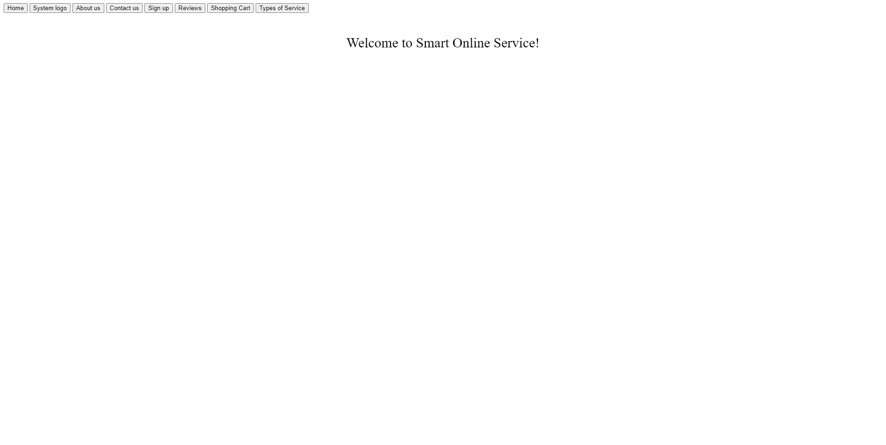

### Tables

Order

* Order ID
  + Unique ID key that designates a specific order with a user
* Data issued
* Date done
* Total payment
  + Total payment of the order
* Payment code
* User ID
  + Unique Current user
* Trip ID
  + Unique Trip ID (NULL if flower is being chosen)
* Flower ID
  + Unique Flower ID (NULL if Trip is being chosen)

User

* User ID
  + User unique ID
* Name
  + User’s name
* Phone number
  + User’s phone number
* Email
  + User’s email address
* Address
  + User’s address
* Postal Code
  + User’s postal code
* Login ID
  + User’s Login identification
* Password
  + User’s Login password
* Balance
  + User’s remaining balance

Trip

* Trip ID
* Source
  + Pick up of user
* Destination
  + Drop off of user
* Distance
  + Total distance of user
* Car ID
* Price

Car

* Car ID
* Car model
* Car code
* Availability Code

Flower

* Flower ID
* Store code
* Price